**Brooklyn torah gazette**

**For parshas noach 5781**

Volume 5, Issue 6 (Whole Number 206) 6 Cheshvan 5781/ October 24, 2020

**Printed L’illuy nishmas Nechama bas R’ Noach, a”h**

**Holocaust Survivor’s Miraculous Reunion with His Brother**

**By** [**Rabbi Levi Welton**](https://www.aish.com/authors/232496271.html)



***Zoltan, surrounded by his brothers Ernie and Alex.***

*Passionate about teaching the Holocaust, Ernie Hollander debated a denier on TV. Then the impossible happened.*

The Satmar Rebbe once said “Anyone who has numbers on their arm has the power to give blessings.”

My father raised me to take this seriously and would always tell me to request a blessing from [Holocaust](https://www.aish.com/ho/) survivors, whom he referred to as “*[Kedoshim](https://www.aish.com/ho/i/48955481.html)*”, aka “The holy ones.”

When I was eleven years old, my father Rabbi BenZion Welton would gently wake me up at 6 AM to bring me to shul. It was still dark outside. As we drove over to Beth Jacob in Oakland, California, I’d nap in the car. Then we’d walk down the thin hallway to the small “morning services” chapel tucked into a forgotten corner behind the magnificent main sanctuary.

I walked in the shadow of my father towards the door. I remember hearing the muffled sounds of prayer as my nostrils widened to take in the scent of freshly brewed coffee and deliciously old books. I sat on the pew in between the two great luminaries of my childhood, my father and Chabad Rabbi Yehuda Ferris.

The chapel could barely house the two dozen people that gathered there every morning to pray. There was only one person whom my father would never let me leave without shaking his hand. This was Holocaust survivor Ernie Hollander, of blessed memory.

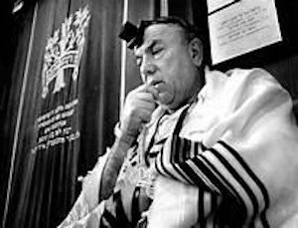

***Ernie Hollander, zt”l***

Although I didn’t know it at the time, Ernie had come from a long line of rabbis that dated all the way back to his family's persecution in the Spanish Inquisition. His great grandfather was HaRav Shlomo (ben Yosef) Ganzfried, author of the *Kitzur Shulchan Aruch*.

Ernie’s father was also a rabbi who owned a flour mill in Czechoslovakia. Ernie and his seven siblings lived happily with their father and mother until the Nazis invaded and murdered his father before his very eyes. Ernie and the rest of the children were sent to Auschwitz. He never saw his mother or sisters again.

When the war ended, Ernie and his baby brother Alex tried to track down the rest of their family but they had all been exterminated during the war. Ernie heard a rumor that his older brother Zoltan had survived the camps only to be hung from a tree by Nazi soldiers fleeing the Allied Forces.

Devastated, Ernie fled to the only place a Jew could always call home: the land of Israel.

While in Israel, he married his wife on a rooftop in Haifa with only $3 to finance their entire ceremony. It was Nov. 29, 1947, the same day the United Nations voted for a resolution that would pave the way for the establishment of the modern State of Israel. Before their wedding ceremony was over, war had broken out. Ernie ran off to join the fight.

*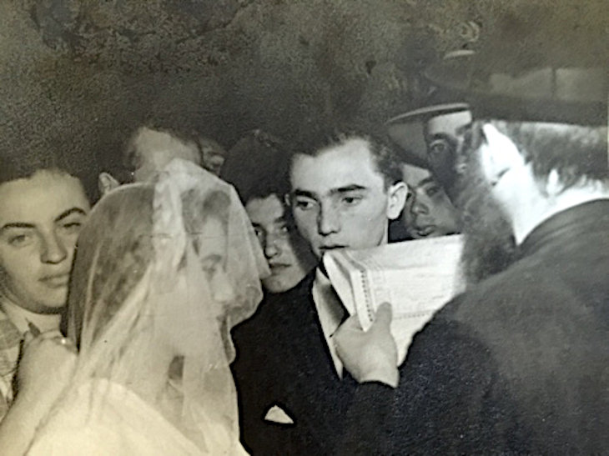****The Hollander's wedding in Haifa***

He served in the Irgun and battled in the Israeli War of Independence. He was wounded three times but he never turned back, even when his wife telegraphed him that their daughter Beverly had been born. Eventually, they left Israel and moved to California. Together, they opened a bakery selling Hungarian strudel in the Jewish shtetl of Oakland. He spoke with a thick accent, loved Yiddish, and referred to G-d as "*Oybeshter*", the One above".

Although he loved the smiles of people who frequented his bakery, his real passion was educating young people about the Holocaust at universities, churches and high schools all over the Bay Area. In 1991, Hollander received an invitation to debate a Holocaust denier on "The Montel Williams Show." Many felt that Ernie shouldn’t give the guy the light of day. But Ernie was not one to turn away from a fight and went anyway.

No one could have ever imagined what would happen next.

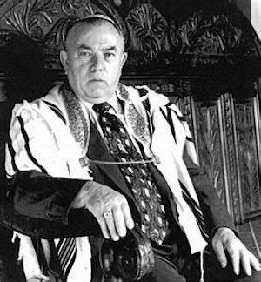

TV stations came to film the debate. It was broadcast all over the country. Ernie didn’t care about all that. He was just happy that he was able to put this guy in his place. The audience must have agreed as they gave Ernie a resounding applause. But thousands of miles away in New York, there was a man named Zika sitting on his couch flipping through the channels. At that exact moment, he flipped to the debate. As he looked at the Holocaust survivor on TV, he rubbed his eyes in disbelief.

*It can't be!* he thought. *This survivor in California is the spitting image of my friend from Serbia. How is this possible?*

Zika picked up the phone and called the number for the Montel Williams show. Through frantic rambling, he told the producers of the show that the impossible had happened. Ernie’s long-lost brother Zoltan was still alive!

Zoltan had indeed been hung by the Nazis back in 1944, but they were in such a rush to flee, they didn’t tie the knots well. Zolton fell between the trees and played dead until he could escape. He spent years wandering Europe and eventually settled in Yugoslavia, having believed his entire family had been murdered in the war. For years, he lived alone.

The Montel Williams show hung up on Zika. They were used to calls like this from crazies just wanting money or fame. But Zika wouldn’t give up. He flew to Serbia to tell his friend in person that a Hollander family from California looked a lot like him. Zoltan gave Zika the names of his grandparents, parents, brothers and sisters along with their birthdays. When Zika returned to New York, he mailed that information to The Montel Williams Show.

**Someone from the Television**

**Show Telephoned the Hollanders**

After receiving the letter, someone from the show telephoned the Hollander’s in Oakland, California. Ernie wasn’t home. But his beloved wife Anna was. She didn’t believe it. “But we have a memorial plaque for Zoltan at Beth Jacob?” She didn’t want to get her husband’s hopes up, only for them to be dashed if it turned out to be a hoax. “But how else would this man in Serbia know all the intimate details of Ernie’s family?” She called Rabbi Zack, the spiritual leader of their synagogue.

The rabbi advised her to tell Ernie. He suggested she not be alone. Several neighbors came over to be with her. When Ernie finally came through the door, she told him to sit down because she had some good news for him and then ran to the kitchen. He heard her sobbing. Ernie followed her inside the kitchen, put his arms around her and asked, “If this is such good news, why are you crying and why do I have to sit down?”

Moments later, everyone in the room was crying. Ernie picked up the phone and called Serbia. For the first time in 52 years, he spoke to his brother Heshy [aka Zoltan]. They spoke for hours. They spoke on the phone every day until The Montel Williams show flew Zoltan from Serbia to Oakland to televise the reunion on live TV.

**Proudly Wearing His Yarmulke**

Ernie waited next to his wife on stage, proudly wearing his yarmulke, with his right hand flitting nervously near his wife's hand. Finally, the announcer let Zoltan enter the room. Their eyes met and the brothers ran to embrace each other. Millions of viewers wept.

My father told me that Ernie told everyone in shul that having his brother, whom he had thought was dead for 50 years, reunited with him was the "the greatest miracle since Moses crossed the sea."

But as a kid, I didn’t know any of this.

For me, Ernie was just the jolly roly-poly “*Gabbai*” (“sexton”) of the shul who always smiled and gave me candy when I came to services. He'd pinch my cheeks and make jokes to make me laugh. I will never forget the reverence and solemn deference which my father always showed Ernie. He taught me and my siblings to do the same.

There are still “*Kedoshim*" who walk among us. Now, more than ever, we need their wisdom. We need their story. They make the world sweeter than the sweetest candy.

*Reprinted from the current website of Aish.com*

**Rabbi Berel Wein on**

**Parshat Noach 5781**



The concluding portion of this week's Torah reading deals with the society that built the great Tower of, and the beginning of the lifetime, and accomplishments of our father Abraham. To me there is a relevancy and immediacy to this theme as it appears in this week's Torah reading.

What is described in the Torah is the creation of a totalitarian society, ruled by dictatorship, fear, and imposed thought and speech control. The Torah text itself sums up the entire situation in its prophetically profound, concise description – “and the society itself spoke only one language and the few same words.” Here you have a description of the destruction of minority opinion, freedom of speech and the right to be different and individualistic. In short, you have the description of North Korea, communist China, Cuba, Venezuela, Nazi Germany, and the former Soviet Union.

You have George Orwell's book “1984,” paraded before us as biblical literature. In such a society, truth, faith and optimism can never flourish. Faith itself is based upon freedom of choice and the worth of the individual. When the state or the government controls the speech, language, and culture of the society that it governs, then there is very little room for the advancement of faith and for societal growth generally.

**Forces of Thought and Speech Control**

One need only look at the wreckage wrought by the forces of thought and speech control that promised the utopian future of the 20th century, This only brought misery to well over 100 million people, without achieving any hint of that utopia being actualized.

The words that the Torah uses to describe the society of the Tower of Babel are striking in their simplicity and accuracy – “one language and the same few words.” It reflects the inability to tolerate other opinions and different words. It is the reason that Abraham is thrown into the ‘furnace of fire’ simply because he dares to be different and to expound the idea of monotheism in a society of enforced paganism.

**Inability to Tolerate Even One Voice of Dissent and Difference**

The forces that ruled at that time could not tolerate even one voice of dissent and difference. The main problem that the Jewish people have faced over their long history is that they are basically different- in speech, dress, outlook, belief, and worldview. Even within the Jewish people there are forces that wish to stifle the faithful minority and to eliminate them from political and social influence and power.

It is interesting to me to note that those who shout the most loudly about individual rights and freedoms rarely are willing to extend them to others who may differ from them in ideology, and social customs.

It is not for nothing that we pride ourselves in being the children of Abraham and willing to stand up alone even against the so-called majority of the current Jewish world. This world has unfortunately lost its way in the name of false gods and bankrupt ideals. It has become totalitarian in its attitudes and behavior towards religion and the Orthodox Jewish world.

But just as our father Abraham persevered and overcame the society of the Tower of Babel, I am confident that this will be the future result in our Jewish world regarding our current situation  - of political correctness, cancel culture and coercive behavior.

*Reprinted from this week’s website of rabbiwein.com*

**Differing Levels of the Perfection of Creation**

**From the Talks of the Lubavitcher Rebbe**

**Rabbi Menachem Mendel Schneerson, Zt”l**

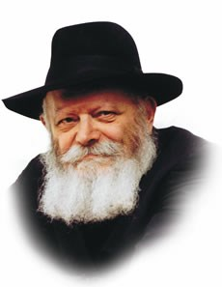

The first two portions of the Torah, Bereishis and Noach, share an essential connection, as both pertain to the creation and existence of the world.

Bereishis, read last week, describes the actual creation, while in Noach, this week's reading, G-d promises that He will sustain the world and never bring another flood.

Symbolically, these two portions represent two different levels of the perfection of creation.

Bereishis represents the world's perfection as it is created by G-d, without man's input or interaction. Noach represents a level of perfection that can only be attained by man's efforts, i.e., the service of teshuva, returning to G-d in repentance.

From the perspective of the first level, there is no possibility for disobeying G-d's will. Were man to disobey G-d, he would automatically lose his right to exist. This is indeed what occurred at the end of last week's portion, when "G-d saw that the evil of man was great... and G-d said, 'I will destroy the man whom I have created.' "

This week, however, we see that man has been given the power to refine himself, and to reach an even higher level of perfection than before his sin. This ability is alluded to by the rainbow, symbolic of G-d's covenant with Noach and G-d's great joy when His children bring the world to even higher levels of perfection through their own actions.

**Reflected in the Particular Names of G-d**

This concept is also reflected in the particular Names of G-d which are used to describe the act of creation and in regard to Noach.

According to the Torah, the world was created by G-d using the Name "Elokim"; likewise, "Elokim" is used an additional 32 times in reference to creation. The Name used in reference to Noach, however, is the ineffable name of G-d which cannot be pronounced.

Elokim, the numerical equivalent of the Hebrew word for "nature," represents a level of holiness that is limited, whereas the Tetragrammaton represents a level which is above all limitations.

We learn from this that the world, as it was created and without man's contribution, has the potential for only a limited revelation of G-dliness; it is solely through the service of man that the higher, infinite and unlimited revelation of G-dliness is achieved.

**The Months in Which These Torah Portions are Read**

This idea is further expressed by the months in which these Torah portions are read.

Bereishis is read in Tishrei, the month of holidays; moreover, at least some of the days corresponding to the week in which Bereishis is read are themselves holidays.

Noach, however, is read in the month of Cheshvan, all of whose weekdays are ordinary days. For as symbolized by Noach, man's essential task in this world is to elevate even the most mundane aspects of life and reveal the unlimited potential for G-dliness contained therein.

*Reprinted from the Parshat Noach 5756 edition of the L’Chaim Weekly, a publication of the Lubavitch Youth Organization. Adapted from Likutei Sichot of the Lubavitcher Rebbe, 5752 Vol. 1*

**Parshas Noach**

**Believing and Not Believing**

**By Rabbi Bentzion Shafier**

**Founder of TheSmuz.com**

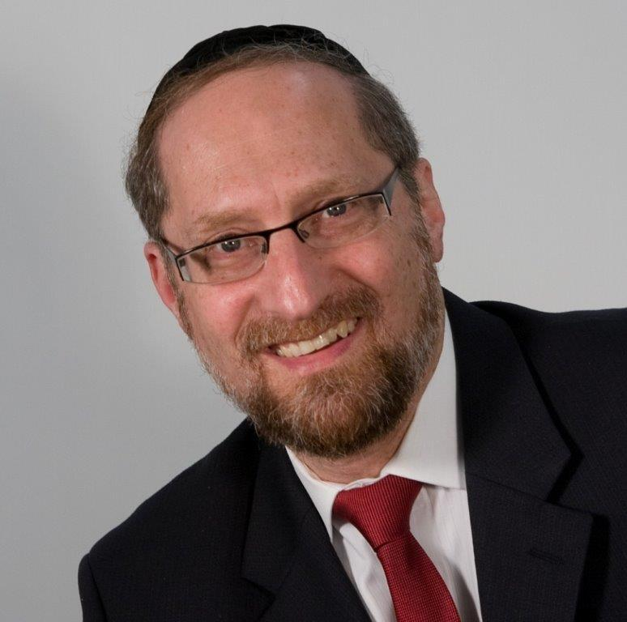

“*And Noach, his sons, and his wife came with him because of the waters of the flood*.” — Bereishis 7:7

HASHEM told Noach that his entire generation was wicked and would be destroyed. Only he, his family, and certain select animals would be saved. When the flood actually began, the *posuk* says that Noach and his family went into the Ark “**because of the waters of the flood**.”

Rashi observes that these words imply that it was the water that caused Noach to go into the *tayva*, not Hashem’s command. Therefore, Rashi says that Noach was “One who believed and didn’t believe.” On one hand, he believed that HASHEM would bring the flood, but on the other, he didn’t believe it would happen. Therefore, he didn’t actually go into the *tayvah* until the rains forced him in.

This Rashi becomes difficult to understand when we take into account some of the background of the event.

**Noach was a Tzaddik**

Noach is called a righteous man, so much so that HASHEM chose him to be the single person to rebuild the human race. So how is it possible that when HASHEM told him there would be a flood, he didn’t believe it?

This question comes into sharper relief when we view the situation in its broader context. Many of the *Rishonim* ask, “Why did HASHEM ask Noach to build the *tayvah*? If HASHEM wanted to destroy the generation and save Noach, there are many ways He could have done it. Why trouble this *tzaddik* to draw the plans, cut the wood, and fit together the pieces? HASHEM could have miraculously saved him without Noach having to become a carpenter.

**A Final Opportunity to Do Tshuvah**

Rashi answers that HASHEM wanted to give the generation one final opportunity to do *tshuvah*. When Noach would work on the *tayvah*, people would see him and ask, “What are you building?”

“HASHEM told me He is going to destroy the world,” he would answer. “The only hope is to repent. Do *tshuvah*.”

For 120 years, while he was building the *tayvah*, Noach was on a mission to convince his neighbors that HASHEM was going to bring a *mabul* and destroy the inhabited world . . . unless they changed their ways.

With this, the question becomes much stronger. Here we have a man whom the Torah calls a *tzaddik*, whom HASHEM spoke to directly. He was told by HASHEM Himself exactly what would happen. He then spent year after year preaching that very message to the people. How is it possible that he didn’t believe it himself?

**The Nature of Man**

The answer to this question is based on understanding the nature of man. When HASHEM created the human, He joined together two divergent elements and fused them into one entity. Part of me only wants to do what is right and proper, only wishes for that which is good, and yearns to be close to HASHEM. That part of me, the *Nefesh Ha’Sichili* or the spiritual soul, is untainted, pure intellect. It is the part of me that understands exactly why I was created.

However, there is another part of me, a *Nefesh Ha’Bahami* or a physical soul. This other part is also vibrant and has needs, but its aspirations, drives, and desires only relate to that which is physical. It only sees the here and now. In its world, if I can’t hear it, feel it, or see it, it doesn’t exist.

When I engage in any spiritual activity, these two components of me are in direct conflict. For instance, when I *daven*, part of me feels a deep, inner yearning to grow ever closer to HASHEM, and part of me is bored. Part of me is aglow because I am connecting to my Creator, and part of me just doesn’t care. The *Nefesh Ha’Bahami* doesn’t see HASHEM, can’t relate to HASHEM, and therefore doesn’t have any connection to anything spiritual.

As long as a person lives, there will be a part of his essence that denies the existence of HASHEM, not because that part is rebellious, nor because it wants to do anything wrong, but because it is incapable of seeing anything that isn’t physical. The more a person grows, the more clearly he relates to his spiritual side, and the less the *Nefesh Ha’Bahami* clouds his vision. However, as long as I am housed in a body, this darkness remains a part of me.

**The Answer to Noach**

The answer to the question seems to be that Noach was a real believer. He had a powerful, unwavering belief that everything that HASHEM said would happen, would indeed come true. But that was only half of him. There was another part of Noach that didn’t see HASHEM, couldn’t relate to Him, and couldn’t see anything beyond the here and the now. That part denied that there would ever be a flood.

Even an *ish tzaddik*, who spent 120 years engaged in teaching that HASHEM was going to bring a flood, was still a human, and as such, he couldn’t fully see it happening. It wasn’t until the rain started that it became real to him, and then he went into the *tayvah*.

**The Darkness of Physicality**

This concept is very relevant to us because no matter what level a person has reached, there will always be a part of him that denies anything spiritual. There will always be a part of me that feels alone in this world because it cannot see HASHEM, nor even relate to anything that is not physical. However, there is another full dimension of me that intuitively knows that HASHEM is right here, running the world, involved in every detail of my life.

*Reprinted from this week’s website on TheShmuz.com This is an excerpt from the [Shmuz on the Parsha book](https://theshmuz.com/product/shmuz-on-the-parsha-book/).*

**The Thicker the Darkness**

**Rabbi David Ashear**

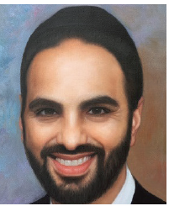

The Pasuk in Yirmiyah says that Hashem will always remember the great love He had for the Jewish people when they left Egypt and followed Him into the desert, not knowing how they were going to eat. Instead of complaining or worrying, they trusted that Hashem would take care of them. That service was so precious to Hashem, even after they saw Him openly.

**They Witnessed the Ten Plagues**

They witnessed the ten plagues and knew He was with them. Imagine if today, when Hashem is so hidden, if someone struggling financially trusts in Hashem instead of worrying, and lives his life happily knowing Hashem is taking care of Him.

How beloved would that person be to Hashem? We live in a time when having Emunah is difficult and serving Hashem is difficult. But, because it is so difficult, our opportunities for greatness are enormous.

It says in the beginning of this week’s Parasha, Bereshit - “The spirit of Hashem hovered upon the surface of the waters. The Midrash says that the spirit is the spirit of Mashiach. This means Hashem created the spirit of Mashiach, even before He created the world.

**Mashiach is the Greatest Man who Ever Lived**

Chazal tell us that Mashiach is going to be the greatest man who ever lived. He is going to wipe out all of our enemies and bring the world to its final Tikun.

Every single generation has been waiting for this holy man to come. Our holy forefathers brought recognition of Hashem into the world. Although they did so much good, their generation did not see Mashiach.

**They Lived with Open Miracles**

Moshe Rabbenu received the Torah on Har Sinai; he led the - דור דעה enlightened generation in the desert for forty years. They lived with open miracles every single day, eating Mann and drinking from the well of Miriam. Yet, their generation did not merit seeing Mashiach. Yehoshua and the –םינקז elders did not see him either. The Nevi’im prophesied about Mashiach, but they did not merit seeing him.

The the men of the great assembly came and illuminated the world in Torah, 120 of the greatest rabbis, but they didn’t see Mashiach either. The generations

of the Tanaim and Amoraim were so great that they were able to revive the dead. However, they did not merit Mashiach.

The Rishonim, the Rambam, Rif and Rashi came and went, but still no Mashiach. The generation of the Bet Yosef and the Arizal, with all of their Kedusha, yet still no Mashiach. There have been so many great Tzadikim throughout the ages, but none of them merited to see Mashiach.

**Which Generation is Going to See this Great Tzadik?**

Which generation is going to see this great Tzadik, who all of history has been waiting for? Which lady is going to be carrying him inside of her? It could be someone living right now, in our generation. We ask, “How can that be? How can such a spiritual giant be born during our days, when the world is on such a spiritual low?” Rav Yerucham writes that it is because “the thicker the darkness, the brighter the light.”

Because we live in such darkness, we have the best opportunity for greatness. We can become the best generation of all time with our small deeds. We don’t see Hashem. We don’t get recognition for our efforts. There are so many things pulling us away from serving Hashem. But if nonetheless, we could still manage to grow and get close to Hashem at this time, we can become so great and

merit Mashiach.

*Reprinted from the Parshas Beresheet 5781 edition of iTorah.com website.*

**We Didn’t Get Here Alone**

**Rabbi Joey Haber**

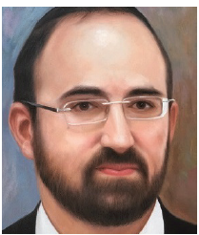

My father often tells a story of a group of adventurous mountain climbers who trained for months in order to prepare to scale an exceptionally tall, steep mountain. Finally, they purchased all their equipment, packed their bags, and set

out on their expedition. They climbed and climbed, utilizing every bit of energy they had, for several days, hoping to make it to the top.

After a grueling trek, and after wondering on many occasions whether perhaps they might not make it, they were almost at the peak. As they approached the mountaintop, they heard people talking. They were startled. How, they wondered, did those people get there?

**“How Did You Get Here?”**

When they finally reached the top, they introduced themselves to the people who were already there. They asked, “How did you get here? Climbing this mountain is about the most difficult feat imaginable. How did you do it?”

“Simple,” they replied. “We were born here.”

This story aptly captures the attitude that virtually all of us have towards someone or something in our lives. Like the people on the top of the mountain, we don’t appreciate how much work went into getting us to where we are.

We tend to take everything for granted, assuming that it just kind of happens by itself. A wife goes shopping for the family, without thinking about how the money ends up in the bank to pay for it all. A husband comes home to a scrumptious dinner and happy, clean, bathed kids ready for bed, without thinking about how much work went into all that.

**Teenage Expectations without Thinking**

Teenagers expect their parents to buy them what they want and bring them where they need to go, without thinking about all the hard work their parents invest to raise them and care for them.

After Adam and Havah violated G-d’s command and ate from the forbidden tree, G-d spoke to Adam and asked him why he did this.

Adam said,– “The woman that You placed beside me, she gave me from the [fruit of the] tree, and I ate.” In other words, Adam turned to Hashem and said: “It’s because of the wife you gave me.”

Havah was Adam’s helper, given to him as a precious gift – but instead of feeling grateful, he complained about her and blamed her for a mistake that was his fault. The Rabbis in the Gemara say that Adam here was – ungrateful. Instead of appreciating what he was given, he complained about it.

So many of us are guilty of this. Our spouse does so much for us, but we take it all for granted, without realizing how much we have because of him or her, and instead complaining about our spouse and blaming our spouse for what goes wrong.

Why is this? Why is it so hard to feel grateful?

**A Natural Desire to Achieve and Accomplish**

Hashem implanted within us a natural desire to achieve, to accomplish, to succeed, in order that we apply ourselves to continue building and improving the world. Because of this innate desire to feel successful, we have a hard time accepting that our successes were not achieved alone.

We want to feel that we reached the mountaintop by ourselves, without any help. But nobody, not even the greatest, most talented person, accomplishes anything by himself or herself. We all depend on so many other people, and of course on Hashem, to achieve.

This is, in essence, what gratitude means. One does not need to buy lavish gifts for people to express gratitude. Gratitude means simply looking around with open eyes, not being afraid to recognize the role other people have played in our successes, and to appreciate them. We will then come to recognize the indispensable role played by Hashem in everything that happens in our lives, and feel grateful and appreciative for all He has given us, each and every day.

*Reprinted from the Parshas Beresheet 5781 edition of iTorah.com website.*

**Thoughts that Count**

**For Parshat Noah**



*And he sent forth a dove* (Gen. 8:8)

Where did it fly? To the land of Israel, which had not been inundated by the great Flood. The Jewish people is likened to a dove. Banished and exiled over the face of the earth, the Jew's heart is nonetheless always drawn to the Holy Land, the land of Israel. *(Be'er Mayim Chaim)*

*Go forth from the ark* (Gen. 8:16)

"Your whole approach is wrong," G-d told Noach. "A person should not remain isolated from the world, safe and secure within the 'four cubits of Torah.' It is not right to think only about yourself. 'Go forth from the ark' -- go out into the marketplace and mingle with the crowd, where you can influence them for good." *(Peninei Torah)*

*In the six hundredth year of Noach's life... all the fountains of the great deep were opened and the windows of heaven were opened* (Gen. 7:11)

According to the Zohar, this refers to the six hundredth year of the sixth millennium (5600 -- corresponding to the civil year of 1840), when the gates of wisdom above (G-dly knowledge, specifically the inner, mystical teachings of the Torah) and the fountains of wisdom below (science and technology) were opened in preparation for the Messianic era, when "The whole earth shall be full with the knowledge of G-d."

*Reprinted from the Parshat Noach 5756 edition of the L’Chaim Weekly, a publication of the Lubavitch Youth Organization.*